Pedigree for Miss E ABCA #417562 Date of Birth: February 13, 2015

]
Pedigree of Roy 266416 x Maid 283794 pups
1 | 2 | 3 | 4 | 5
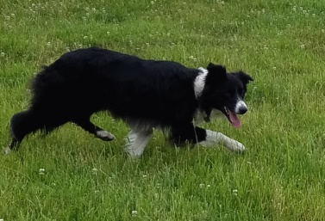  Miss E  ABCA #417562  Medium Black White  Nancy Cox Starkey  Mt. Airy, MD | 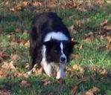  Jim  ABCA #314463  Hubert Bailey  Dawsonville, GA | 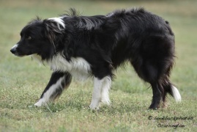  Cap  ABCA #249321  Bill Reed  Piperton, TN | Ben ABCA #156553  Debbie Bailey  Cataula, GA | Donnie ABCA #13918  Ray McDougald, SK
Lacey ABCA #148000
Dale Montgomery, SK
 |  |  | Kate ABCA #175226  MariannaSchreeder  Smyrna, GA | Bill ABCA #41699  R. Morris Petrowski, TN
Jane ABCA #82365
Ray Essary, TN
 |  | 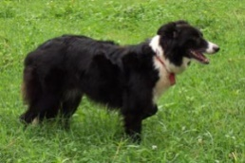  Redcreek Molly  ABCA #164241  Bob Ford  Jonesbourough, TN | Imp. Jim ABCA #133041  A.MacRae/Bob Ford  Jonesborough, TN | Scott ISDS #189240  D. Brady, N. Ireland
Cran ISDS #181688
F.W. MacGregor, Scotland
 |  |  | Milly ABCA #92988  Bob Ford  Jonesborough, TN | Don ISDS #204906  Rusty Manuel
Sue of Kitscoty ABCA #21123
M. Scott, Airdrie, AB
 | 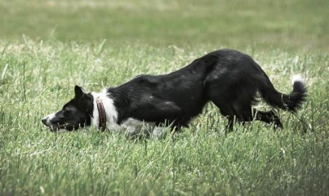  Emma  ABCA #317021350351  Cindy Carrington  Mineral Bluff, GA | 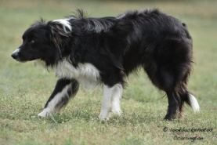  Cap  ABCA #249321  Bill Reed  Piperton, TN | Ben ABCA #156553  Debbie Bailey  Cataula, GA | Donnie ABCA #13918  Ray McDougald, SK
Lacey ABCA #148000
Dale Montgomery, SK
 |  |  | Kate ABCA #175226  MariannaSchreeder  Smyrna, GA | Bill ABCA #41699  R. Morris Petrowski, TN
Jane ABCA #82365
Ray Essary, TN
 |  | Taco  ABCA #243826  J + T Gardin  Limestone, TN | Imp. Rob ABCA#117504  Jeff Hoffman  Barbourville, VA | Mal ISDS #169139  Dal Jones, Wales
Eira ISDS #188061
J W Evans, Dyfed, Wales
 |  |  | Annie ABCA #156469  Tom Forrester  Strasburg, VA | Bud (Apache) ABCA #66938  Tom Forrester, Strasburg, VA
Maid ABCA #90302
Tom Forrester, Strasburg, VA

