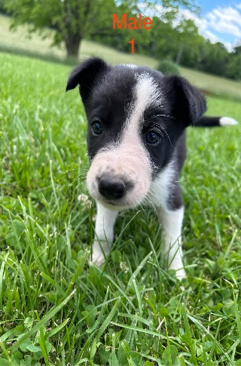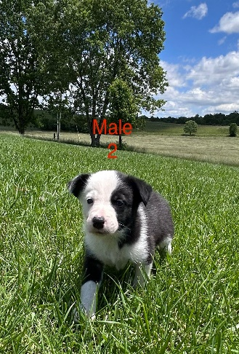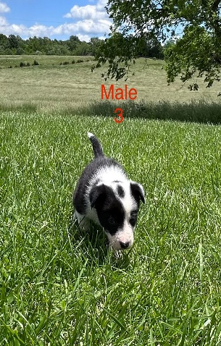
Puppies
Warner Family Farms
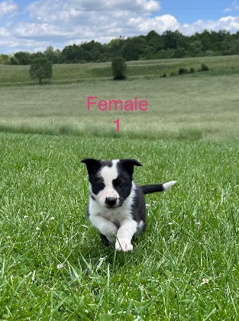
SIRE
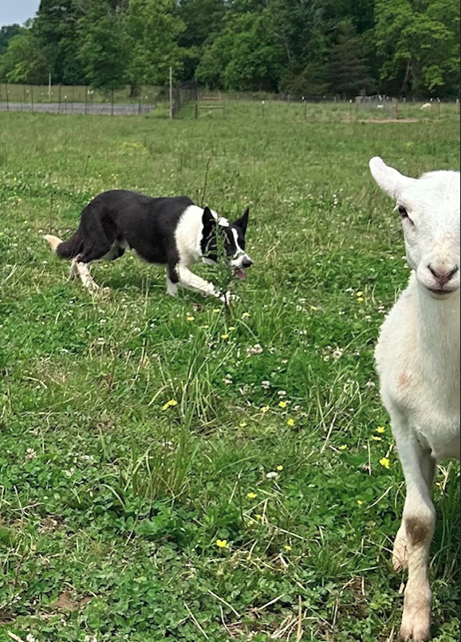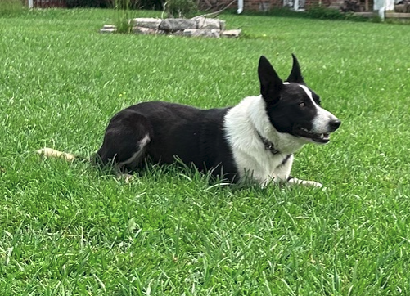
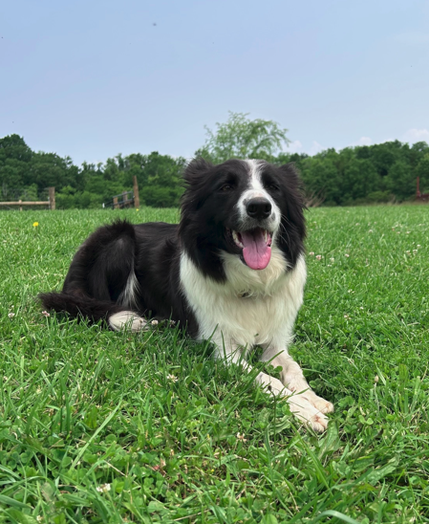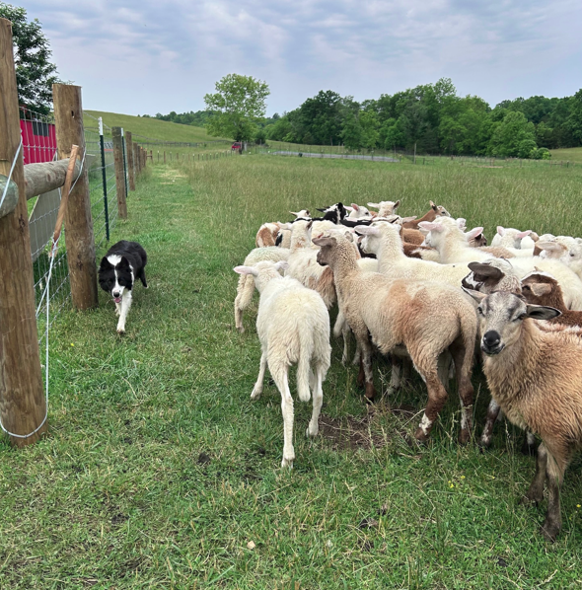
DAM
Working Border Collie puppies for sale born April 15, 2025. Three males and two females available. They are up to date with vaccinate. Sire is strong with pace and lots of eye. Dam is eager and loves to work. Both actively work on our cattle and sheep ranch helping move or with day to day activities. Located in Harrodsburg KY.
Additional information and videos available upon request. Price $1,000 / ea
Contact: Jack Warner by phone/text at (859) 613-5538 or by email at warnerfamilyfarms25@gmail.com

